**Practical 1**

**Aim: Using Packet Tracer Create a Basic Network of Two Computers using appropriate network Wire.**

**Steps:**

**(1)To Start this Practical First Open the Software Cisco Packet Tracer Instructor. From the Software**

**Select a Generic PC from End Devices by default it has name as PC-PT PC0 now from same options**

**Select an another PC by default it has name as PC-PT PC1.Now from Routers option select a**

**Router 1841 by default it will have a name as Router 0.**

**(2)Connect all the three Devices with a Copper-Cross Wire.**

**(3)Now click on PC 0 then go to Desktop from Desktop select IP Configuration option. Inside IP**

**Configuration option select as Static option. Now enter three fields namely as IP Address (Give the**

**value as 192.168.1.1) you do not have to provide the second field as Subnet Mask it is filled by the**

**Software by itself at last you have to give the Default Gateway as (192.168.1.10)**

**(4)Now click on PC 1 then go to Desktop from Desktop select IP Configuration option. Inside IP**

**Configuration option select as Static option. Now enter three fields namely as IP Address (Give the**

**value as 192.168.1.2) you do not have to provide the second field as Subnet Mask it is filled by the**

**Software by itself at last you have to give the Default Gateway as (192.168.1.10).**

**(4) Now click on Router 0 (1841) go to Fast Ethernet 0/0 option and give the Default Gateway**

**Address as (192.168.1.10) Subnet Mask will be generated automatically by software.**

**(5)Now all the connections are been done. Now click on Message option and try to send a message**

**from PC 0 to PC 1. A Box of your recent activity will be visible to you as below. Images are given**

**below.**

|  |  |
| --- | --- |
| **PC Name** | **IP Address** |
| **PC0** | **192.168.1.1** |
| **PC1** | **198.168.1.2** |

**Default Gateway:192.168.1.10**

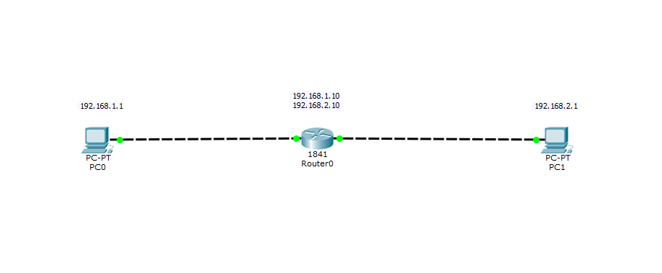

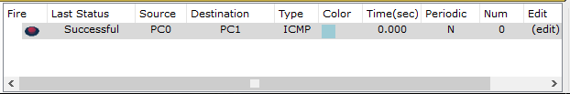

**Practical 2**

**Aim: Using Packet Tracer connect Multiple (Minimum 6) Computers using Layer to Switch.**

**Steps:**

1. **Open the software Cisco Packet Tracer Instructor and then select Six PC’s.**
2. **As done in Practical 1 provide the IP Address and Default Gateway values as given below for all**

**PC Devices :**

|  |  |
| --- | --- |
| **PC Name** | **PC IP Address** |
| **PC 0** | **192.168.1.1** |
| **PC 1** | **192.168.1.2** |
| **PC 2** | **192.168.1.3** |
| **PC 3** | **192.168.1.4** |
| **PC 4** | **192.168.1.5** |
| **PC 5** | **192.168.1.6** |

1. **The Default Gateway will be same for all the Six PC’s which is 192.168.1.10.**
2. **Now go to option Switches then select the Switch 2950-24. Take two switches for this Practical.**
3. **Connect first three PC’s with Switch 0 and rest three with Switch 1 with a help of Copper Straight - through wire and the connection of two switches with Copper-Cross over wire.**
4. **Now as all connections are done try sending a message from any Source to Destination.**

**Images are shown below.**

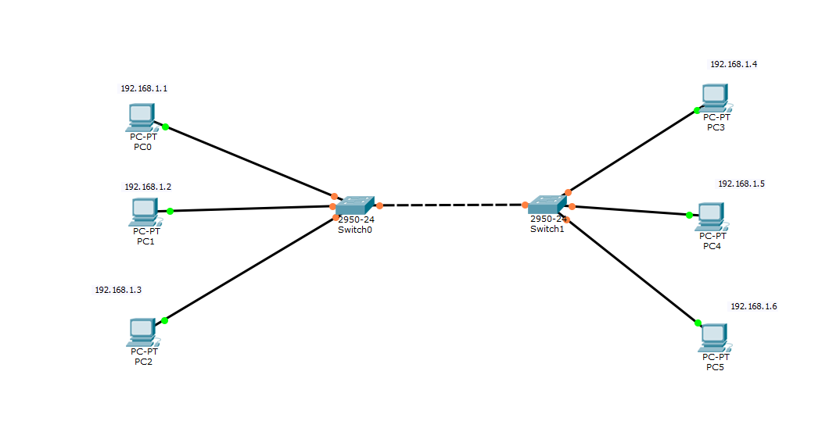

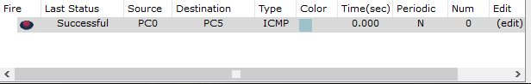

**Practical 3**

**Aim: Using packet Tracer Connect a network in Triangular shape with three Layers Two Switches and every switch have three Computers. Verify their Connectivity with Each other.**

**Steps:**

1. **Open the software Cisco Packet Tracer Instructor and then select Nine PC’s.**
2. **As done in Practical 2 provide the IP Address and Default Gateway values as given below for all**

**PC Devices :**

|  |  |
| --- | --- |
| **PC Name** | **PC IP Address** |
| **PC 0** | **192.168.1.1** |
| **PC 1** | **192.168.1.2** |
| **PC 2** | **192.168.1.3** |
| **PC 3** | **192.168.1.4** |
| **PC 4** | **192.168.1.5** |
| **PC 5** | **192.168.1.6** |
| **PC 6** | **192.168.1.7** |
| **PC 7** | **192.168.1.8** |
| **PC 8** | **192.168.1.9** |

1. **The Default Gateway will be same for all the Nine PC’s which is 192.168.1.10 .**
2. **Now go to option Switches then select the Switch 2950-24. Take three switches for this Practical.**
3. **Connect first three PC’s with Switch 0 and next three with Switch 1 and rest three with Switch 2 with a help of Copper Straight-through wire and the connection of three switches with Copper-Cross over wire.**
4. **Make the connection of Switches in triangular form as shown in Image. Now as all connections are done try sending a message from any Source to Destination. Images are shown below.**

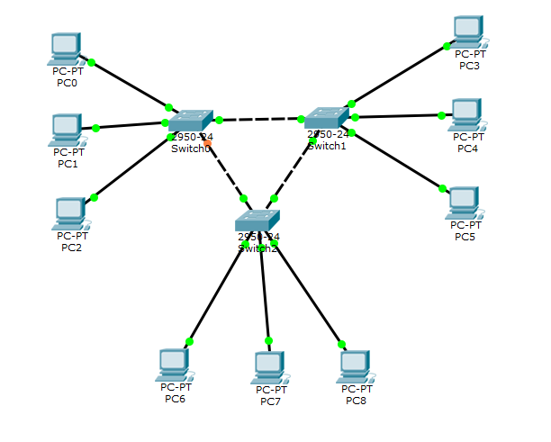

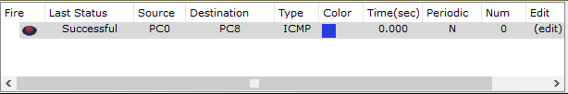

**Practical 4**

**Aim: Using Packet Tracer create a Wireless Network of Multiple PC’s using appropriate access Point.**

**Steps:**

1. **Select the following devices as stated below:**
2. **1 Generic PC.**
3. **1 Laptop.**
4. **1 Smart Phone**
5. **1 Access Point.**
6. **Now First Select the Access Point and go to Config in Config go to Port 1 option and give SSD as Network123 and give password as 12345678 by selecting authentication as WPA2-PSK PSK Pass Phrase.**
7. **Go to PC0 and in Config switch OFF the PC and then select WMP300N and add in the PC0 and ON the PC now go to Desktop and go to PC Wireless and go to connect option and go select the Network123 and give password as 12345678 and click on connect now your wireless connection is done similarly follow the steps for remaining generic Laptop and Smartphone.**
8. **Now as the connection is done try sending the message.**

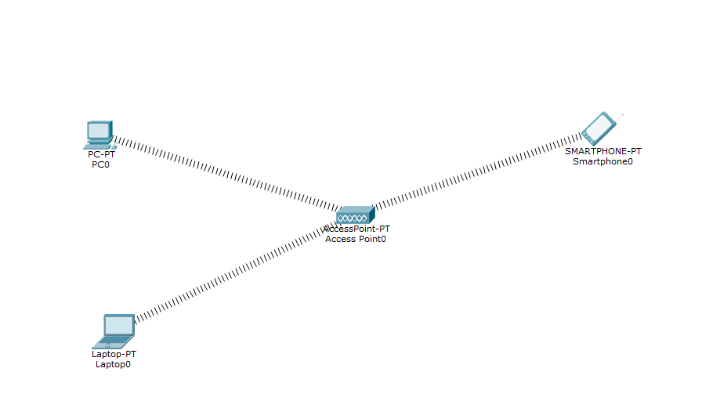

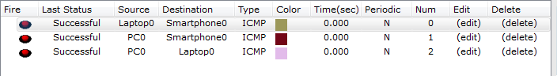

**Practical 5**

**Aim: Using a Wire Shark Network Analyzer set the Filter for ICMP, TCP, HTTP, UDP, FTP and perform the Respective Transactions to Show or Prove that network analyzer is Working.**

**Steps :**

1. **From the left corner of the toolbar, select Selection on leftmost panel in bottom toolbar and then from right hand side panel select Selection on adjacent panel , drag and drop devices on screen referred in below table :**

|  |  |  |
| --- | --- | --- |
| **Selection on leftmost panel** | **Selection on rightmost panel** | **ID** |
| **End devices** | **PC-PT** | **PC0** |
| **End devices** | **PC-PT** | **PC1** |
| **End devices** | **Laptop-PT** | **Laptop0** |
| **End devices** | **SMARTPHONE-PT** | **Smartphone0** |
| **Wireless devices** | **Access Point-PT** | **AccessPoint0** |
| **Switches** | **2950-24** | **Switch0** |
| **Routers** | **1841** | **Router0** |

1. **From the leftmost Panel , provide wired connection by using copper straight-through wire from PC1,AccessPoint0, Router0 to switch0.**
2. **Click on PC0 in Physical tab view Physical view of CPU. Switch OFF the CPU and then remove the PT-HEADPHONE module from CPU and then add WMP300N module to CPU and Switch ON the CPU**
3. **Click on Laptop0 in Physical tab view Physical view of CPU. Switch OFF the CPU and then remove the PT-HEADPHONE module from CPU and then add WMP300N module to CPU and Switch ON the CPU**
4. **Click on PC0 and go to desktop for IP configuration Provide IP address as “192.168.1.1” and default gateway as “192.168.1.10”**
5. **Click on PC1 and go to desktop for IP configuration Provide IP address as “192.168.1.2” and default gateway as “192.168.1.10”**
6. **Click on Laptop1 and go to desktop for IP configuration Provide IP address as “192.168.1.3” and default gateway as “192.168.1.10”**
7. **Click on AccessPoint0 select Config . Click on Port 1. Assign SSID=Network, and in frame Authentication select WPA2-PSK assign Pass Phrase of your choice to AccessPoint0.**
8. **Click On PC0, select Desktop and click on Wireless Connections. Now Click On Connect. SSID of AccessPoint0 will appear in list of available connections. Click On SSID of AccessPoint0 i.e. Network and then Click on Connect. After clicking on Connect a dialog will appear asking for Pass Phrase. Enter the Pass Phrase and then Click On Connect.**
9. **Now Click On Laptop0, select Desktop and click on Wireless Connections. Now Click On Connect. SSID of AccessPoint0 will appear in list of available connections. Click On SSID of AccessPoint0 i.e. Network and then Click on Connect. After clicking on Connect a dialog will appear asking for Pass Phrase. Enter the Pass Phrase and then Click On Connect.**
10. **Click On Smartphone0 and select Config. Click on Wireless0.Enter SSID of AccessPoint0 i.e. Network and then in Authentication frame select WPA2-PSK and enter Pass Phrase.**
11. **Pass the message and verify their connectivity with each other.**

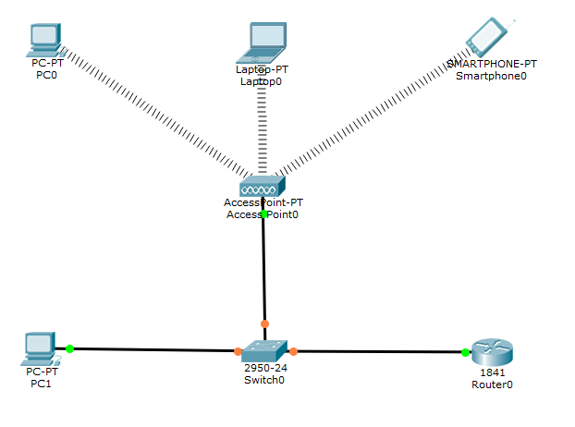

**Output:**

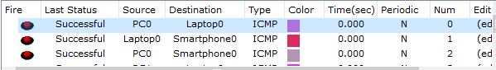

**Practical 6**

**Aim: Using Cisco Packet Tracer Create a connection between Router, Switch and Pc’s.**

**Steps:**

1. **From the left corner of the toolbar, select Selection on leftmost panel in bottom toolbar and then from right hand side panel select Selection on adjacent panel , drag and drop devices on screen referred in below table :**

|  |  |  |
| --- | --- | --- |
| **Selection on leftmost panel** | **Selection on rightmost panel** | **ID** |
| **End devices** | **PC-PT** | **PC0** |
| **End devices** | **PC-PT** | **PC1** |
| **End devices** | **PC-PT** | **PC2** |
| **End devices** | **PC-PT** | **PC3** |
| **Switches** | **2950-24** | **Switch0** |
| **Switches** | **2950-24** | **Switch1** |
| **Routers** | **1841** | **Router0** |
| **Routers** | **1841** | **Router1** |

1. **From the leftmost panel , provide wired connection by using copper straight-through wire from Router 0 to Switch0 to PC0 and PC1, and connect two routers with the Serial-DTE wire.**
2. **In Router0, go to Physical tab, Switch off power and replace the existing module with WIC-2T in it and switch ON the power.**
3. **Go to config tab of Router0 and select Fast Ethernet 0/0 in it. Switch on port status, put IP address as 10.0.0.10, Subnet Mask as 255.0.0.0. Select Serial 0/0/0, switch ON port status and set IP to 192.168.1.10.**
4. **In Router1, go to Physical tab, Switch off power and replace the existing module with WIC-2T in it and switch ON the power.**
5. **Go to config tab of Router0 and select Fast Ethernet 0/0 in it. Switch on port status, put IP address as 20.0.0.20, Subnet Mask as 255.0.0.0. Select Serial 0/0/0, switch ON port status and set IP to 192.168.1.11.**
6. **Select PC0, go to Desktop tab set IP address to 10.0.0.1 Subnet Mask to 255.0.0.0. Default Gateway to 10.0.0.10.**
7. **Select PC1, go to Desktop tab set IP address to 10.0.0.2 Subnet Mask to 255.0.0.0. Default Gateway to 10.0.0.10.**
8. **Select PC2, go to Desktop tab set IP address to 10.0.0.3 Subnet Mask to 255.0.0.0. Default Gateway to 10.0.0.10.**
9. **Select PC3, go to Desktop tab set IP address to 10.0.0.4 Subnet Mask to 255.0.0.0. Default Gateway to 10.0.0.10.**
10. **Pass the message and verify their connectivity with each other.**

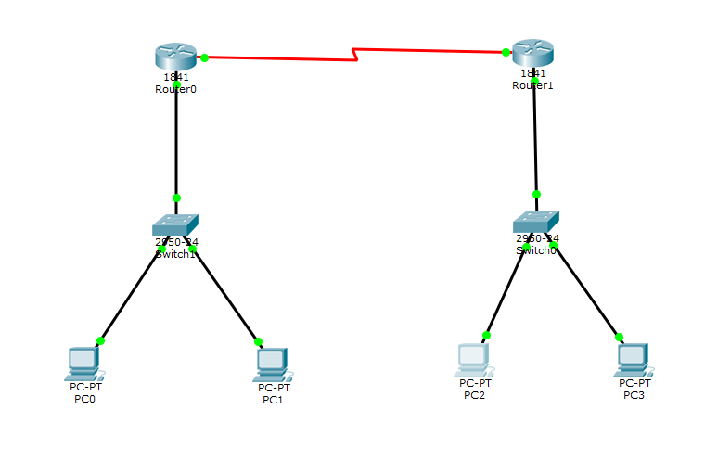

**Output:**

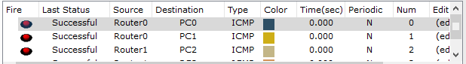

**Practical 7**

**Aim: Using Linux Terminal or Windows CMD execute the following**

**network Command and note the output.**

**Commands are as follows:**

**(a)PING.**

**(b)tracert.**

**(c)NetStat .**

**(d)arp.**

**(e)ipconfig.**

**(a)PING**

**Ping is a computer network administration software utility used to test the reachability of a host on an Internet Protocol (IP) network. It is available for virtually all operating systems that have networking capability, including most embedded network administration software.**

**Ping measures the round-trip time for messages sent from the originating host to a destination computer that are echoed back to the source. The name comes from active sonar terminology that sends a pulse of sound and listens for the echo to detect objects under water.**

**Ping operates by sending Internet Control Message Protocol (ICMP) echo request packets to the target host and waiting for an ICMP echo reply. The program reports errors, packet loss, and a statistical summary of the results, typically including the minimum, maximum, the mean round-trip times, and standard deviation of the mean.**

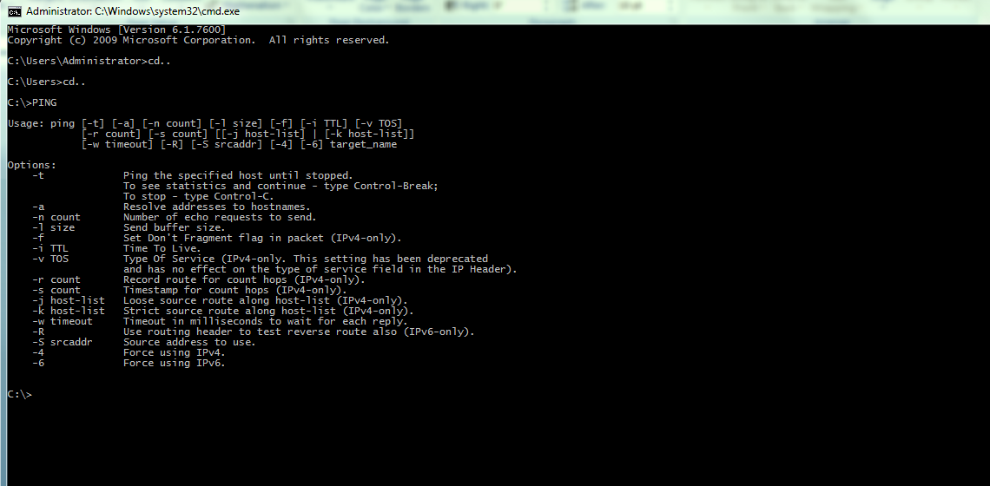

**(b)tracert**

**In computing, traceroute and tracert are computer network diagnostic commands for displaying the route (path) and measuring transit delays of packets across an Internet Protocol (IP) network. The history of the route is recorded as the round-trip times of the packets received from each successive host (remote node) in the route (path); the sum of the mean times in each hop is a measure of the total time spent to establish the connection. Traceroute proceeds unless all (three) sent packets are lost more than twice; then the connection is lost and the route cannot be evaluated. Ping, on the other hand, only computes the final round-trip times from the destination point.For Internet Protocol Version 6 (IPv6) the tool sometimes has the name traceroute6 or tracert6.**

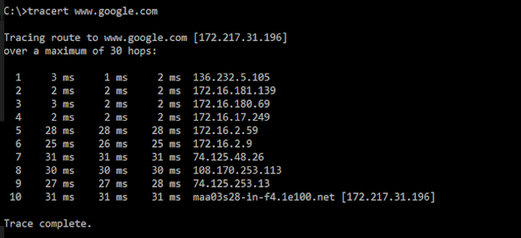

**(c)netstat**

**In computing, netstat (network statistics) is a command-line network utility that displays network connections for Transmission Control Protocol (both incoming and outgoing), routing tables, and a number of network interface (network interface controller or software-defined network interface) and network protocol statistics. It is available on Unix-like operating systems including macOS, Linux, Solaris and BSD, and is available on IBM OS/2 and on Microsoft Windows NT-based operating systems including Windows XP, Windows Vista, Windows 7, Windows 8 and Windows 10.It is used for finding problems in the network and to determine the amount of traffic on the network as a performance measurement.[1] On Linux this program is mostly obsolete, although still included in many distributions.**

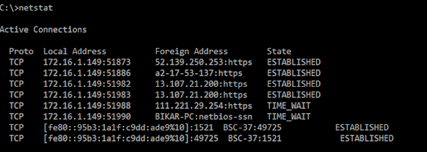

**(d)arp**

**The Address Resolution Protocol (ARP) is a communication protocol used for discovering the link layer address, such as a MAC address, associated with a given internet layer address, typically an IPv4 address. This mapping is a critical function in the Internet protocol suite. ARP was defined in 1982 by RFC 826,[1] which is Internet Standard STD 37.ARP has been implemented with many combinations of network and data link layer technologies, such as IPv4, Chaosnet, DECnet and Xerox PARC Universal Packet (PUP) using IEEE 802 standards, FDDI, X.25, Frame Relay and Asynchronous Transfer Mode (ATM). IPv4 over IEEE 802.3 and IEEE 802.11 is the most common usage.In Internet Protocol Version 6 (IPv6) networks, the functionality of ARP is provided by the Neighbor Discovery Protocol (NDP).**

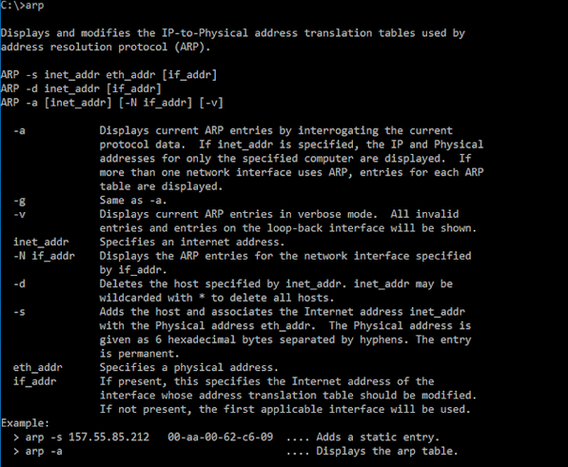

**(e)ipconfig**

**In computing, ipconfig (internet protocol configuration) is a console application of some operating systems that displays all current TCP/IP network configuration values and refresh Dynamic Host Configuration Protocol (DHCP) and Domain Name System (DNS) settings.[1]**

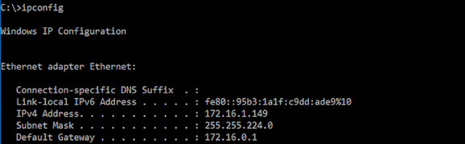

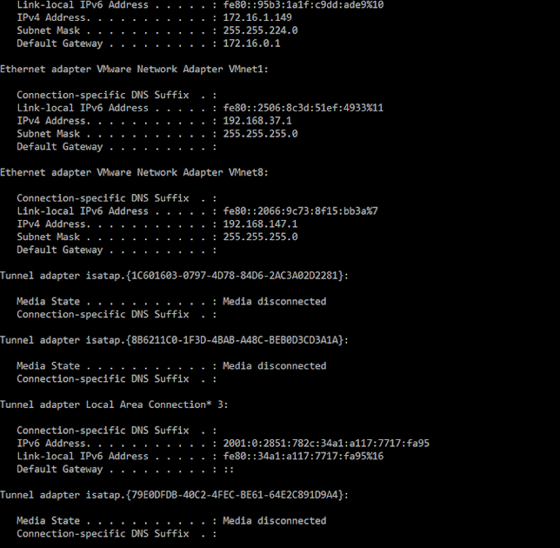

**Practical : 8**

**Aim Using Cisco Packet tracer establish between Server and PC with the help of Router and Switch.**

**Steps:**

**(1)Select the Following Devices:**

**(A)1 Generic PC.**

**(B)1 Switch.**

**(C)1 Router.**

**(D)1 Server.**

**(2)For connection of PC to Switch(Copper Straight through wire) and Switch to Router connect with (Copper straight through wire) and from Router to Server by using a Copper Cross Over Wire as shown in Figure Below.**

**(3)Now click on PC0 go to Desktop in Desktop go to IP Configuration give IP Address as 192.168.1.1 and Default gateway as 192.168.1.10.**

**(4)Now Click on Server go to Desktop in Desktop go to IP Configuration give IP Address as 10.0.0.2 and Default gateway as 10.0.0.10.Now go to Config in Config go to FastEthernet0 give IP Adress as 10.0.0.2 and “ON” the Services.**

**(5)Now Click on Router go to Config in Config go to FastEthernet0/0 give Ip Address as 192.168.1.10 and subnet mask and “ON” the services. Similarly go to FastEthernet0/1 give IP Address as 192.168.1.10 and subnet mask and “ON” the services and give IP Address as 10.0.0.2 and Subnet mask.**

**(6)Now as Connections are Done try sending messages.**

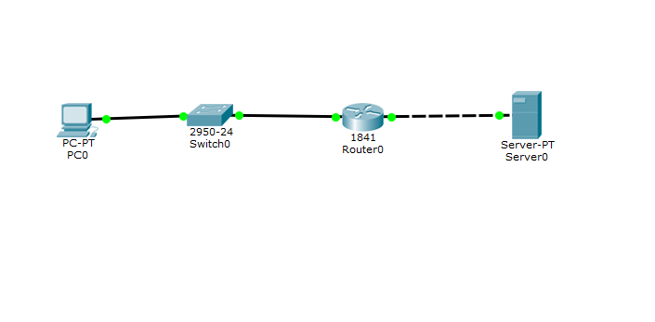

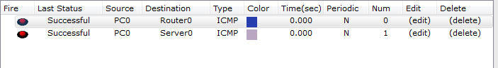

**Practical:9**

**Aim: Perform Mesh Topology network connection using Cisco packet tracer.**

**Steps:**

**(1)Select the following devices as stated below:**

**(a)4 Generic PC’s.**

**(b)4 Switches.**

**(2)Connect all the Switches with each other in a Square Format then connect the First and Fourth PC and at last connect Second and Third PC Diagonally connection should be made by a Copper Cross Wire.**

**(3)Connect the PC1 with Switch1,PC2 with Switch2,PC3 with Switch3 and PC4 with Switch4 connection should be made using Copper Straight through Wire.**

**(4)IP Address table:**

|  |  |
| --- | --- |
| **PC Name** |  |
| **PC 0** | **192.168.0.1** |
| **PC 1** | **192.168.0.2** |
| **PC 2** | **192.168.0.3** |
| **PC 3** | **192.168.0.4** |

**Give Default gateway as 192.168.1.10**

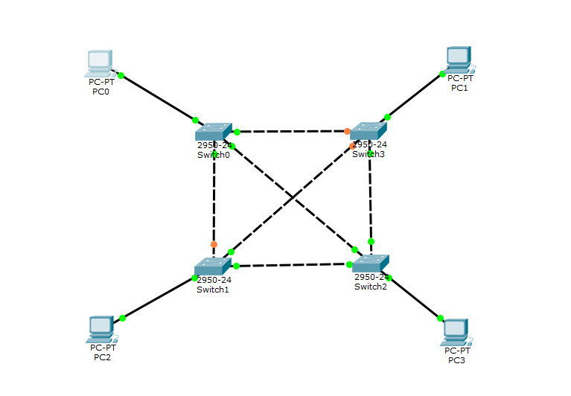

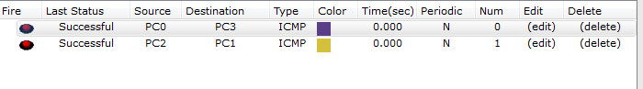

**Practical 10**

**Aim: using a DHCP Server Configuration and a Switch create a communication**

**between 2 generic PC’s and 2 Laptops**

**(1)First Select the following devices stated below:**

**(a)1 Server**

**(b)1 Switch**

**(c)2 generic PC’s**

**(d)2 Laptops**

**(2)By using a Copper Straight through wire connect all the PC’s and Laptops with Switch.**

**(3)Now by using a Copper Straight through wire connect the Server and Switch with each other.**

**(4)Click on Server and go to Desktop in desktop IP Configuration and give IP address as 192.168.0.1 and subnet mask as default.**

**(5)Now close the window again click on server and go to Services in Services on left column click on DHCP and just on the Service option and give Default gateway as 192.168.0.1 and DNS Server as 10.0.0.1 and click on Save Button.**

**(6)Now click on First PC go to Desktop in Desktop go to IP Configuration and click on DHCP automatically IP address will be generated and requested indicating connection is made.**

**(7)Similarly Do above step for all generic PC’s and Laptops.**

**(8)Now Try sending messages from one Destination to a particular Source.**

